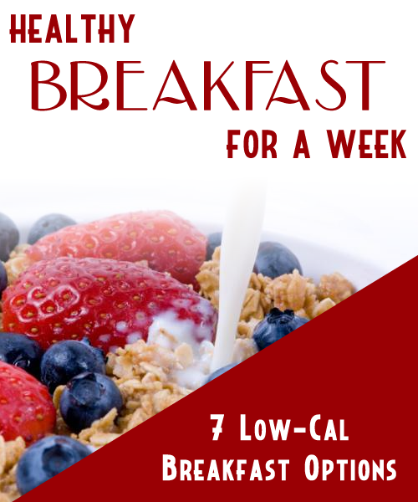
Table Of Contents

Wake Up Sandwich 3

Apple Oatmeal 3

Melon Smoothie 3

Whole Wheat Pancakes 3

Morning Power Bar 3

Texan Omelette Wrap 3

Muesli 3

Wake Up Sandwich

You will want to wake up to this early morning breakfast sandwich.

Ingredients

1/4 cup liquid egg (whites OK too)
2 tbsp light shredded cheese
2 tbsp chopped green pepper
1 tbsp sodium reduced ham
Pepper to taste
1/8 tsp Italian seasoning (optional)
1 whole-grain English muffin, toasted

Directions

1. Find a bowl that is about the same size around as an english muffin and dishwasher safe.

2. In the bowl, mix together egg, cheese, pepper, ham, ground pepper and Italian seasoning (if using). Microwave on high for 1 minute. Turn the egg over and microwave for another 30 seconds to 1 minute.

3. Place egg on the toasted English muffin.

(Makes 1 Serving)

Calories Per Serving: 247
Apple Oatmeal

A delicious and warming breakfast treat

Ingredients

3 cups apple juice
1/2 tsp ground cinnamon
1 1/2 cups quick oats
1/2 cup chopped apple
1/4 cup maple syrup
1/4 cup raisins
1/4 cup chopped walnuts
4 tbsp fat free vanilla yogurt

Directions

1. Combine apple juice and cinnamon in a medium saucepan. Bring to a boil.

2. Stir in oats, chopped apple, maple syrup and raisins.

3. Reduce heat and cook until most of juice is absorbed, stirring occasionally. Fold in walnuts.

4. Top each bowl with a tablespoon of yogurt.

(Makes 4 Servings)

Calories Per Serving: 271
Melon Smoothie

This smoothie harnesses the natural sweetness of the Watermelon.

Ingredients

3 cups watermelon chunks
1 small banana, chopped
1 cup ice
1 1/2 cups 0% fat vanilla yogurt

Directions

1. Put watermelon chunks, chopped banana, ice and yogurt in a blender. Blend until desired smoothness.

2. Pour into glasses.

(Serving Size 12 oz)

Calories Per Serving: 158
Whole Wheat Pancakes

A healthier choice than pre mixed pancake batters. Top them wisely as that will add calories,

Ingredients

1 cup whole wheat flour
1 tsp baking powder
1/2 tsp baking soda
1/8 tsp salt
1 egg, lightly beaten
1 cup low-fat buttermilk
2 tbsp honey

Directions

1. Whisk whole-wheat flour, baking powder, baking soda and salt in a medium bowl.

2, In a small bowl, combine egg, buttermilk and honey.

3. Make a well in dry ingredients and stir in egg and buttermilk mixture. Allow batter to rest for a few minutes.

4. Set a nonstick frying pan to medium-high heat. Drop batter by 1/4 cupfuls on to griddle or pan. Cook until the edges begin to dry and bubbles appear in the pancakes. Flip and cook for 1-2 minutes more.

(Makes 8 pancakes)

Calories Per 2 Pancake Serving: 188
Morning Power Bar

Power up your morning workout with this healthy power bar.

Ingredients

1 cup old-fashioned rolled oats
1/4 cup slivered almonds
1 tbsp flaxseeds, preferably golden
1 tbsp sesame seeds
1 cup unsweetened whole-grain puffed cereal (see Note)
1/3 cup currants
1/3 cup chopped dried apricots
1/4 cup creamy almond butter (see Note)
1/4 cup turbinado sugar (see Note)
1/4 cup honey
1/2 teaspoon vanilla extract
1/8 teaspoon salt

Directions

1. Preheat oven to 350°F. Coat an 8-inch-square pan with cooking spray.

2. Spread oats, almonds, flaxseeds and sesame seeds on a large, rimmed baking sheet. Bake until the oats are lightly toasted. Transfer to a large bowl. Add cereal, currants, apricots and raisins; toss to combine.

3. Combine almond butter, sugar, honey, vanilla and salt in a small saucepan. Heat over medium-low, stirring frequently, until the mixture bubbles.

4. Immediately pour the almond butter mixture over the dry ingredients and mix with a spoon or spatula until no dry spots remain.

5. Transfer to the prepared pan and press the mixture down firmly to make an even layer.

6. Refrigerate until firm, about 30 minutes

(Makes 8 Bars)

Calories Per 1 Bar Serving: 244 calories

Texan Omelette Wrap

This wrap is a healthy taste of the south west.

Ingredients

1 large egg
1 large egg white
1/2 teaspoon hot sauce, such as
Freshly ground pepper, to taste
1 tablespoon chopped scallions
1 tablespoon chopped fresh cilantro, or parsley (optional)
2 tablespoons prepared black bean dip
1 9-inch whole-wheat wrap, (see Ingredient note)
1 teaspoon canola oil
2 tablespoons grated pepper Jack or Cheddar cheese
1 tablespoon prepared green or red salsa, (optional)

Directions

1. Set oven rack 6 inches from the heat source; preheat broiler.

2. Stir together eggs, hot sauce and pepper, scallions and cilantro (or parsley), if using.

3. If black bean dip is cold, warm it in the microwave on High for 10 to 20 seconds. Place wrap between paper towels and warm in the microwave on High for about 10 seconds. Spread bean dip over the wrap, leaving a 1-inch border all around.

4. Brush oil over a 10-inch nonstick skillet; heat over medium heat. Add the egg mixture and cook 20 to 30 seconds. Place the skillet under the broiler and broil just until the top is set, 20 to 30 seconds.

5. Slide the omelet onto the wrap. Sprinkle with cheese. Roll the wrap and serve with salsa/

(Makes 1 Serving)

Calories Per Serving: 321
Muesli

A classic breakfast that is power packed with dried fruit and healthy nuts.

Ingredients

300g jumbo oats
100g Allbran
25g wheatgerm
100g dark raisins
140g ready-to-eat apricots , cut into chunks
50g golden linseeds

Directions

1. Mix everything in a large bowl.

2. Store for up to 2 months, airtight.

3. Serve with Milk if you prefer

Calories Per 1 Cup Serving: 124

